ECA0302 – SIGNALS AND SYSTEMS
Ragavarshini R
192512027
CO3 – EXP 7 - 14
7-To analyze Fourier series of continuous-time periodic signals and analyze their waveform characteristics.
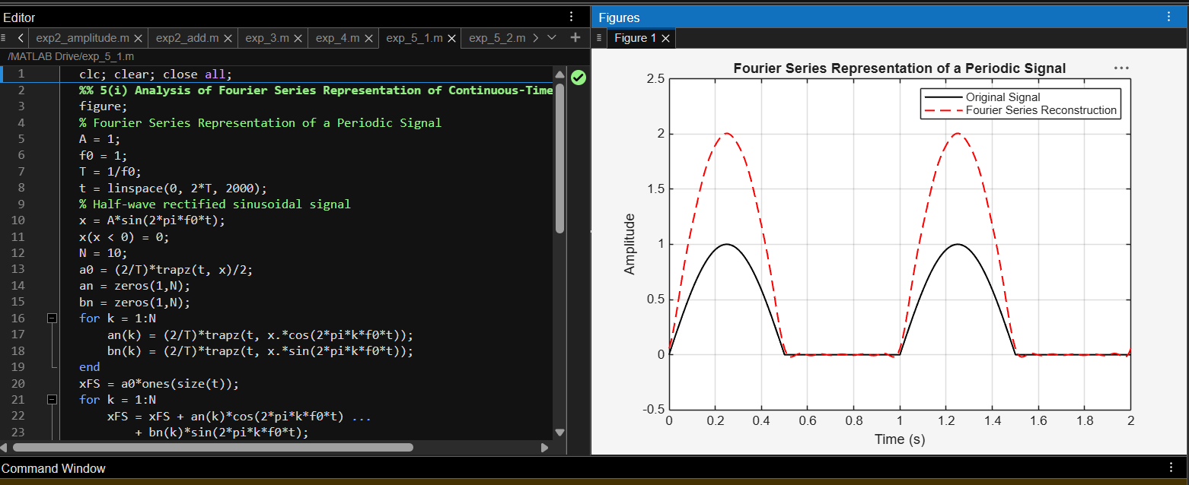
8- To reconstruct periodic signals using Fourier series and verify the reconstructed waveform with the original signal.

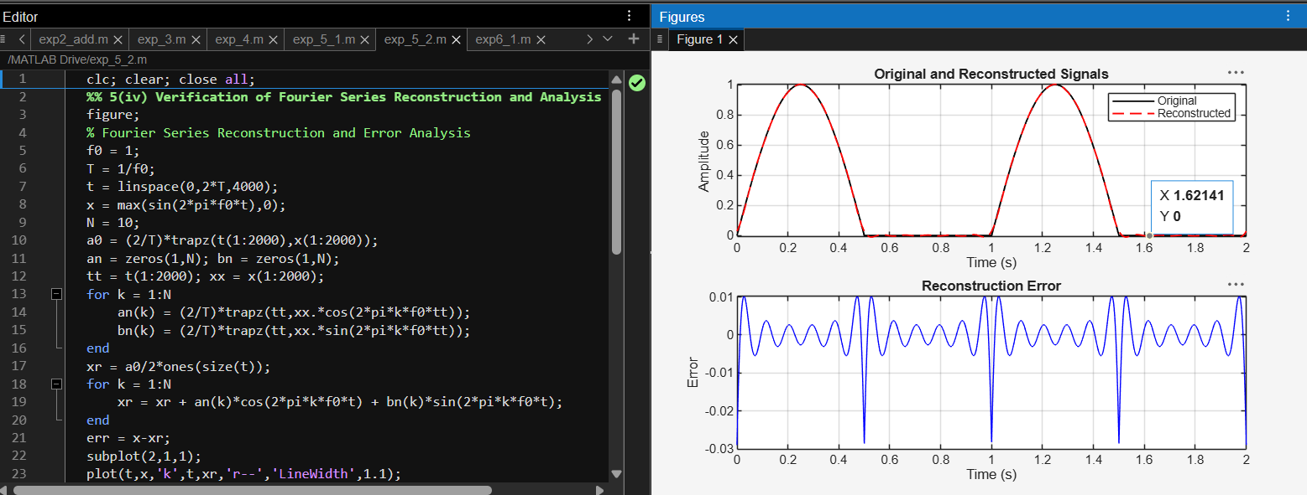

9 - To verify Parseval’s relation for continuous-time periodic signals and analyze the relationship between time-domain and frequency-domain power.

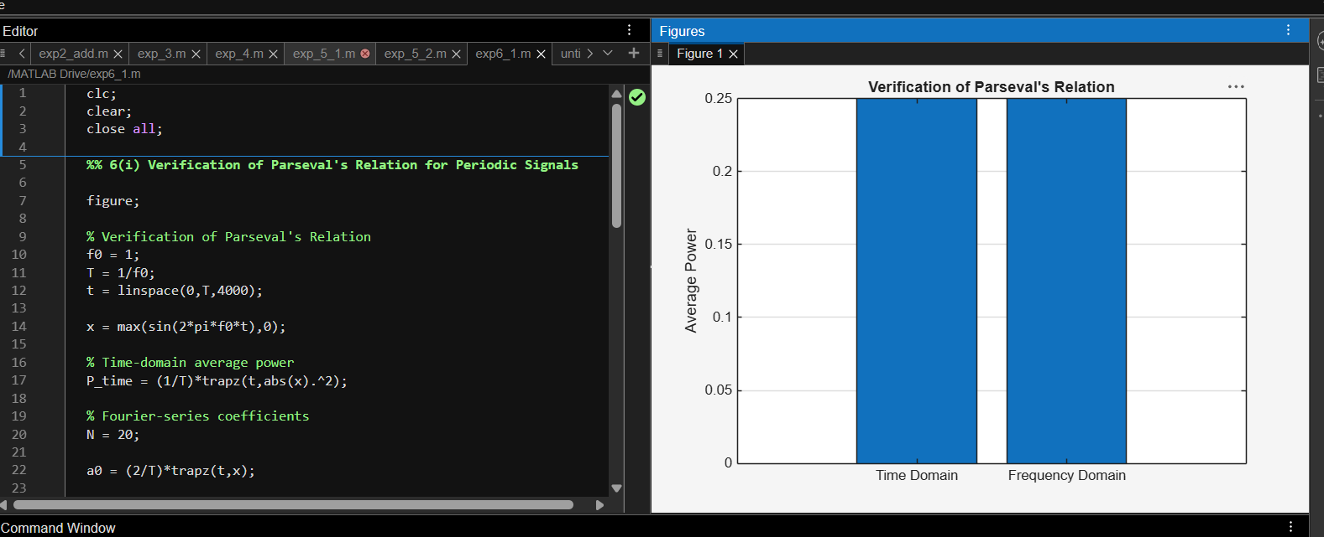

10 -To compare the total power obtained in the time domain with the harmonic power distribution in the frequency domain.
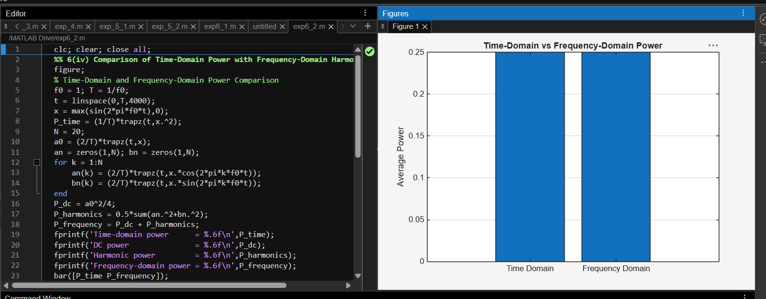

11 - To determine the magnitude and phase spectra of continuous-time signals and analyze their significant spectral components.
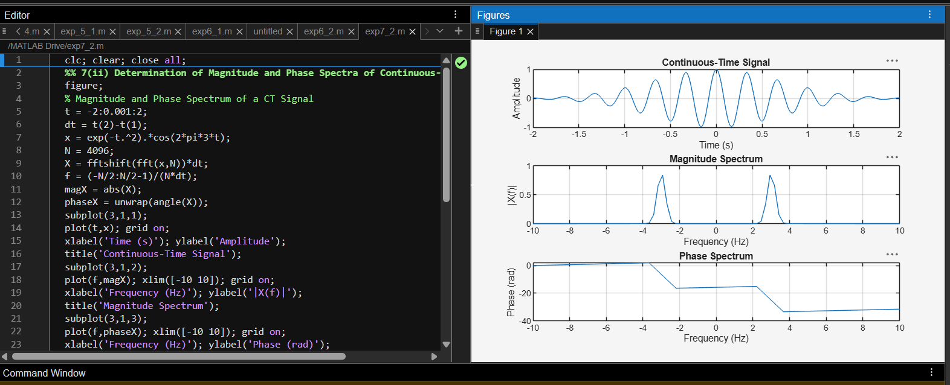
12 - Verification of Fourier Transform Properties and Frequency-Domain Characteristics
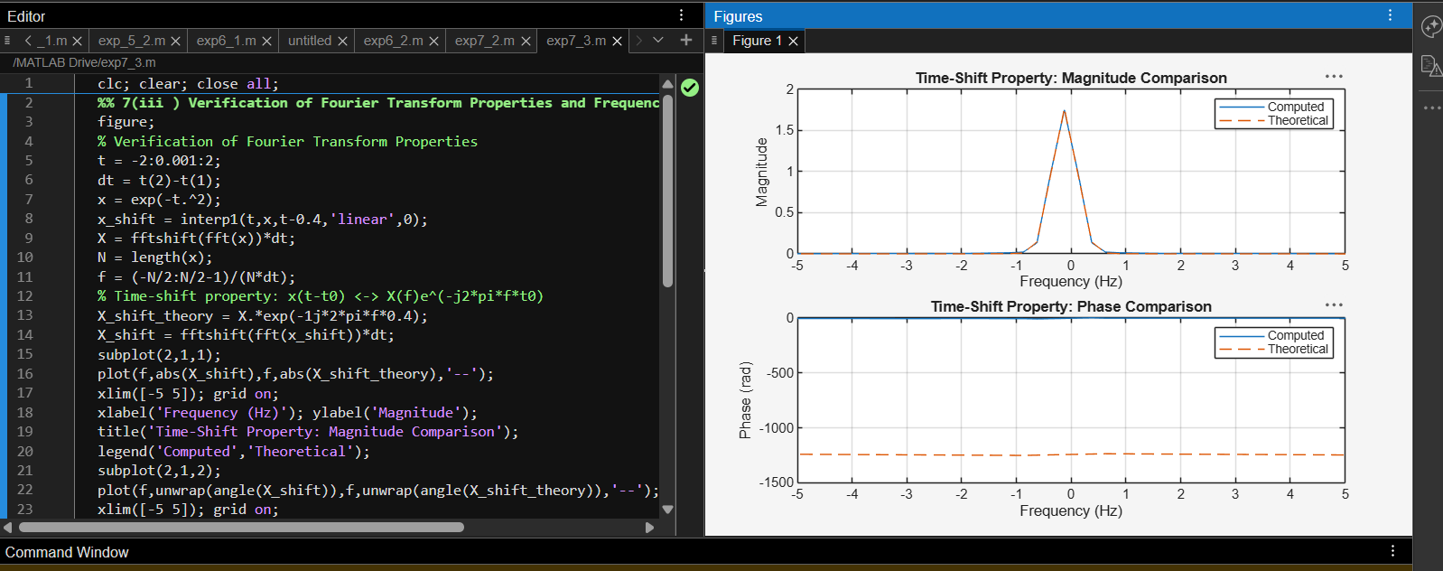
13 - To determine the inverse Laplace transform of a given frequency-domain representation and reconstruct the corresponding time-domain signal.
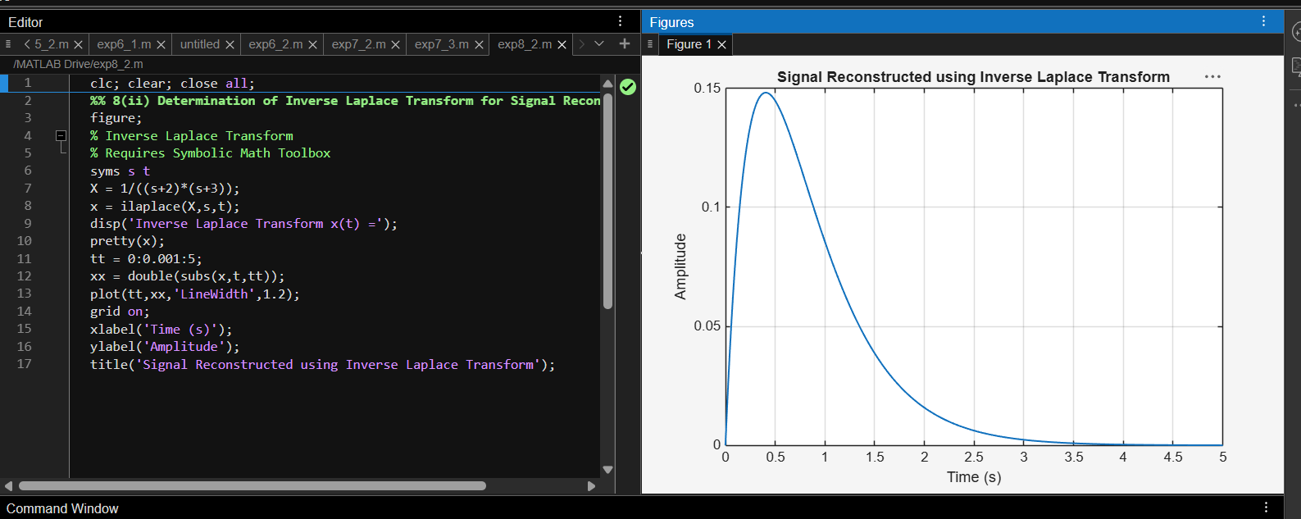

14 - To determine the Region of Convergence (ROC) of Laplace transforms and analyze its significance in characterizing continuous-time signals and systems.
